

Names: Yasar Azimi

Final project

Project Documentation

**Ayesha Yousaf Rawan**

Class: ITC 410

2022/11/30

Stories have power, and we read them because we want to experience something out of the ordinary. So that’s why for this time I have chosen something that can being us joy when reading and help us escape our stressful life. The domain I have chosen for this project is “WEBNOVEL”, it’s an online website for connecting those who want to use their spare time reading something that can bring them solace from their daily life.

The first thing people will see in our site is the login page that people can use to get access to the Sign Up page, where they can type their information in order to get access to our site. This page is connected to our data base where they information is stored and can only be accessed by the admin alone. But the user is allowed to change their information or update them when they want. The people can Save their data in the data base, Update their data, Read their data, Delete their data, or Read their data. From where they can get access to our login page, where they can use their account to get access to our site. And the info in it.

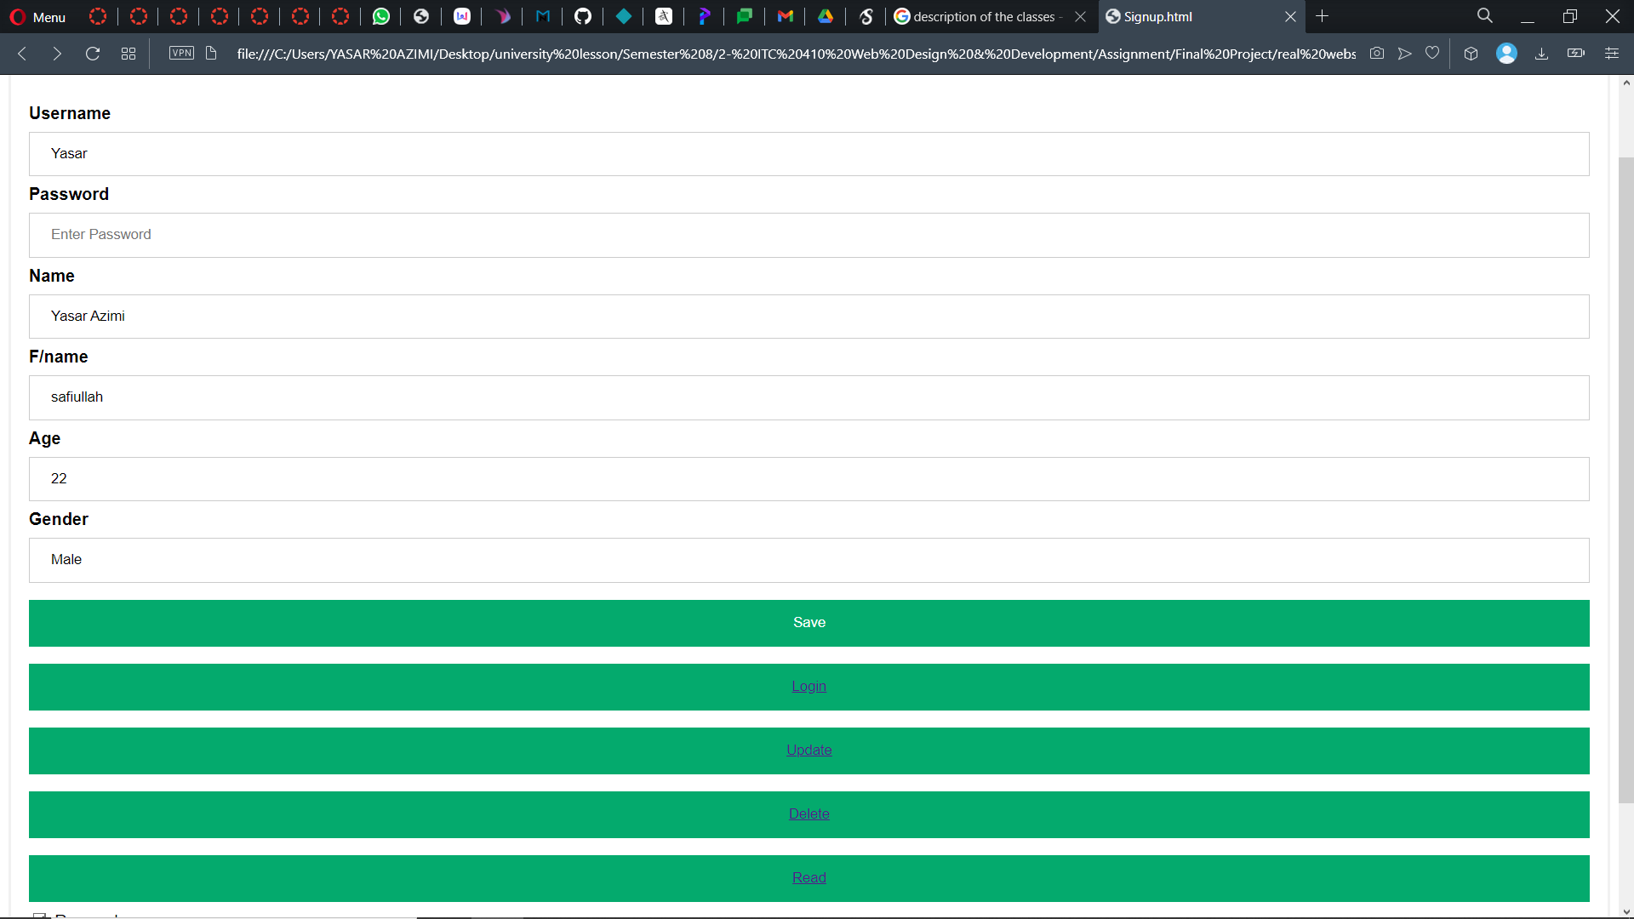

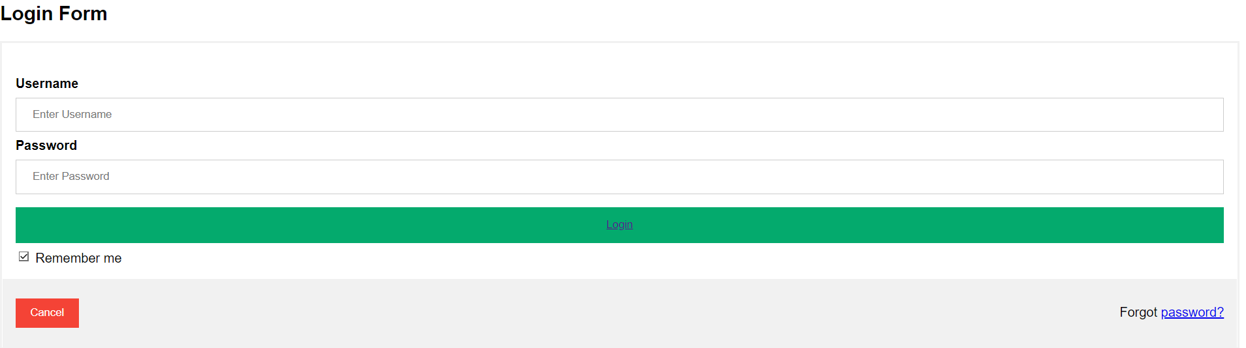

Getting to our site will lead us to the main page. Where they can use the buttons above to get to the place they want to.

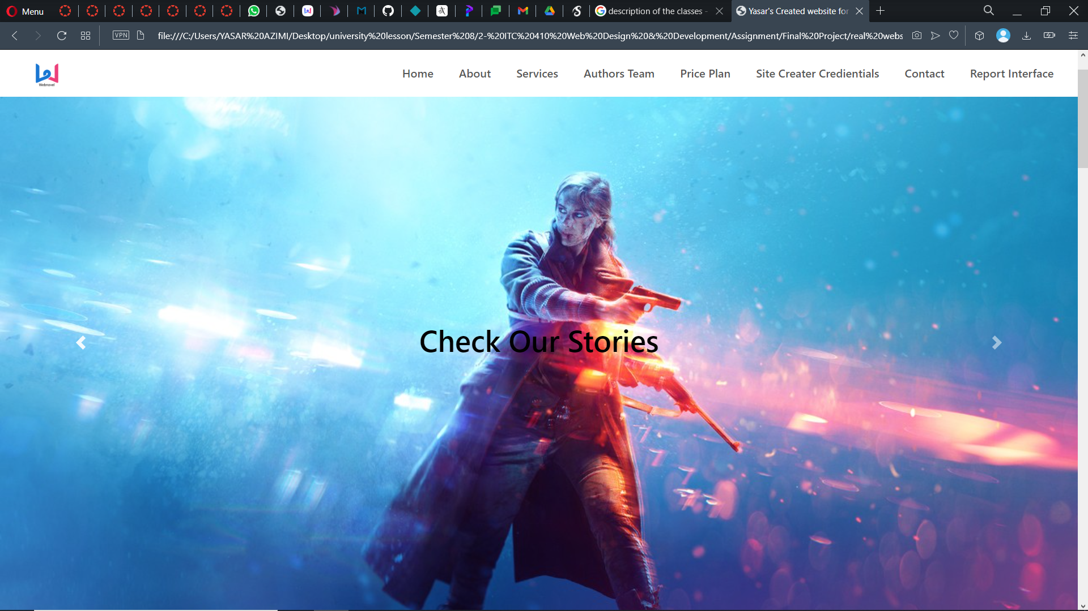

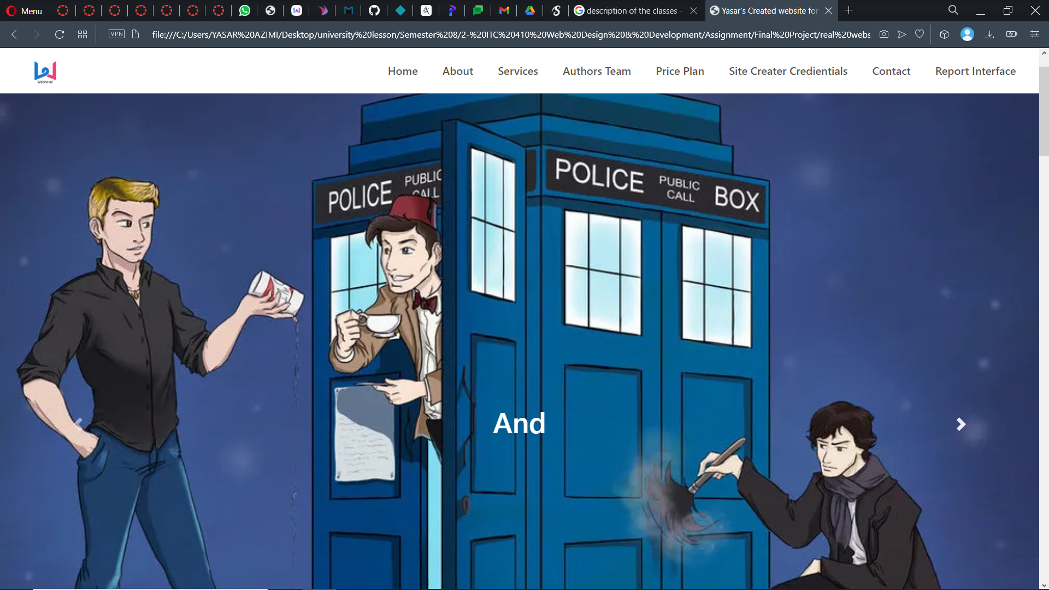

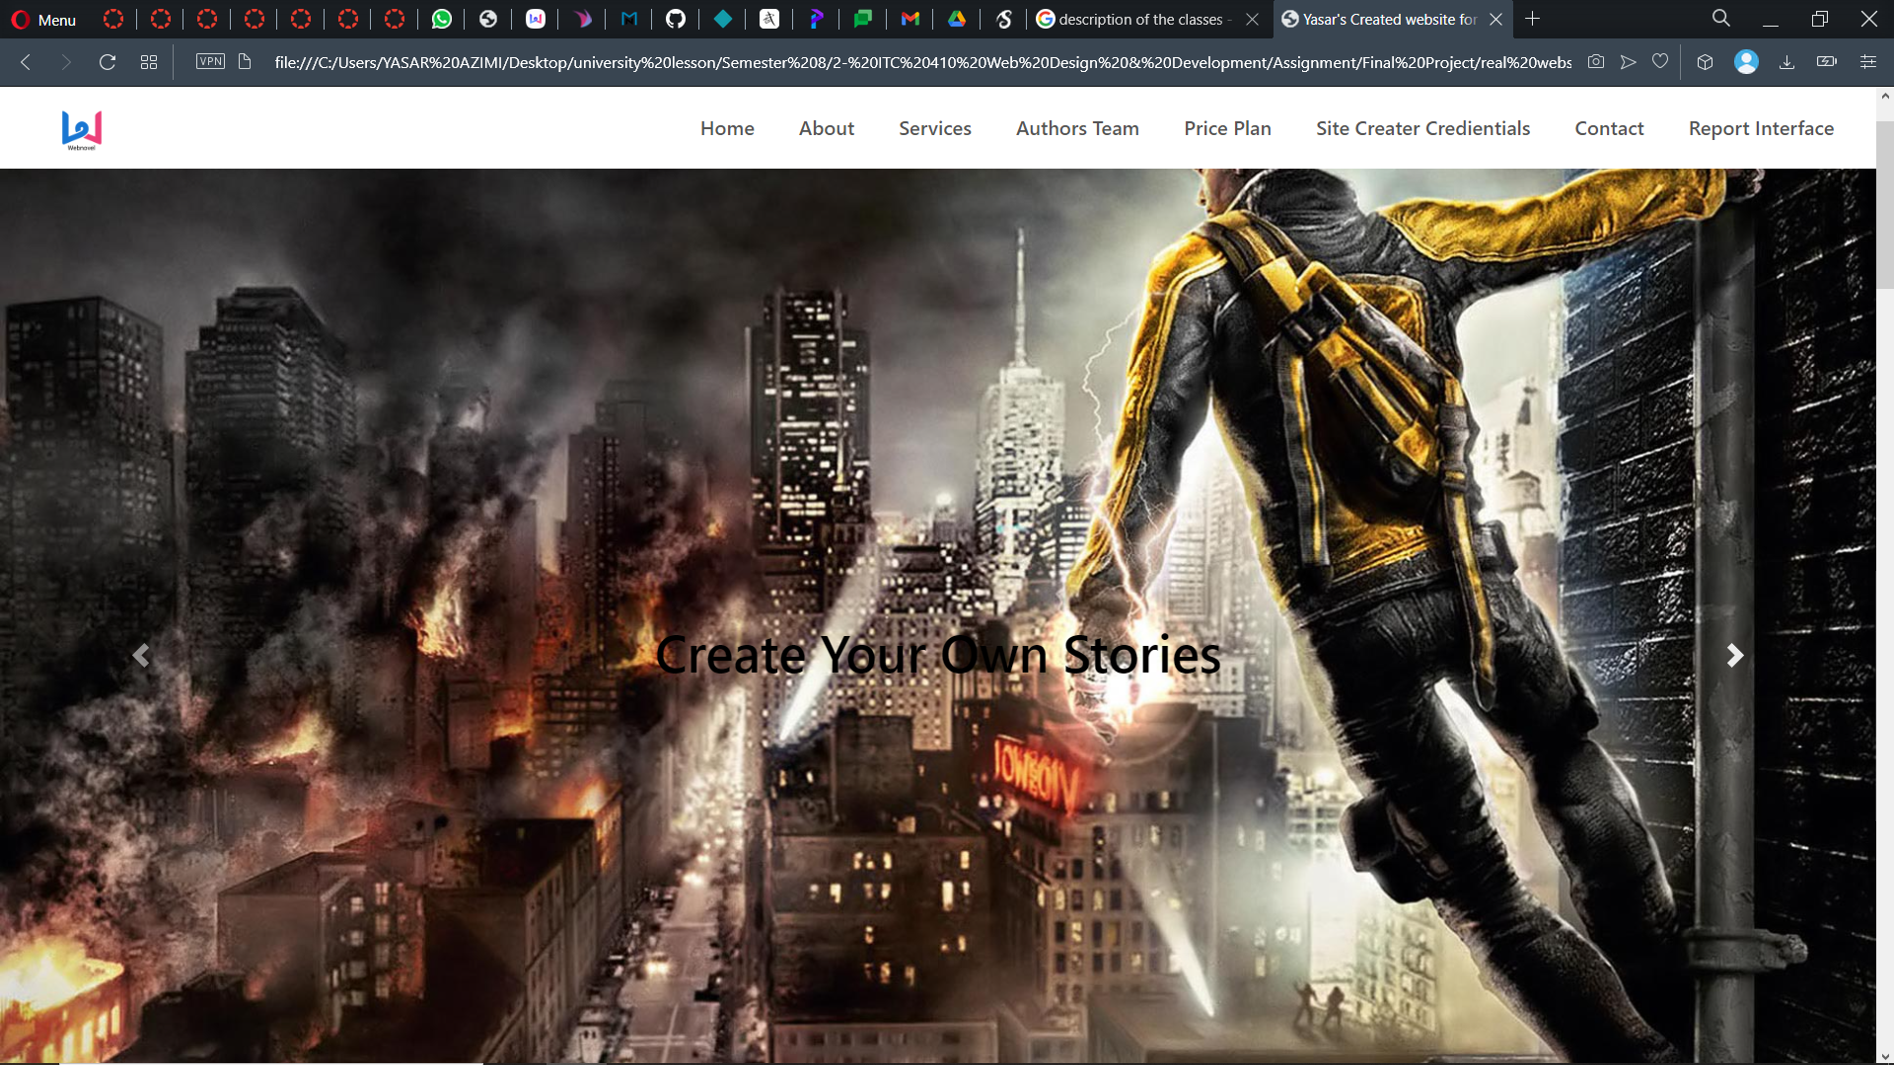

The Webnovel site will have 4 parts dedicated to the things user want to read. The first part will have the Novels. Novels are the stories that haven’t been written by anyone (original stories), and are not based on a show or another story. An example of this can be books like Harry Potter, Shadow Hunters, and the Vampire Diaries.

The second part of the site that the user can get access to is the Fanfiction part. Fanfiction are stories that are based on a world that already exist, for example it could be a story that is written to change the ending of a show you like. So these are the “WHAT IF’S” of the Novel World.

The third part of the site are the Comics, which are basically adaptations of the novels and stories in pictures. Comics are the picture form of a novel and story and is sometimes similar to a movie/anime.

The fourth part of the site is the tournament sections that will be held every 2-3 months, this will help authors to publish their work on the site and make it so that others can see their work and let them (the people) be the judge of whether their work is good or not.

Now once you are in our site you can click on about to get the basic information of our site.

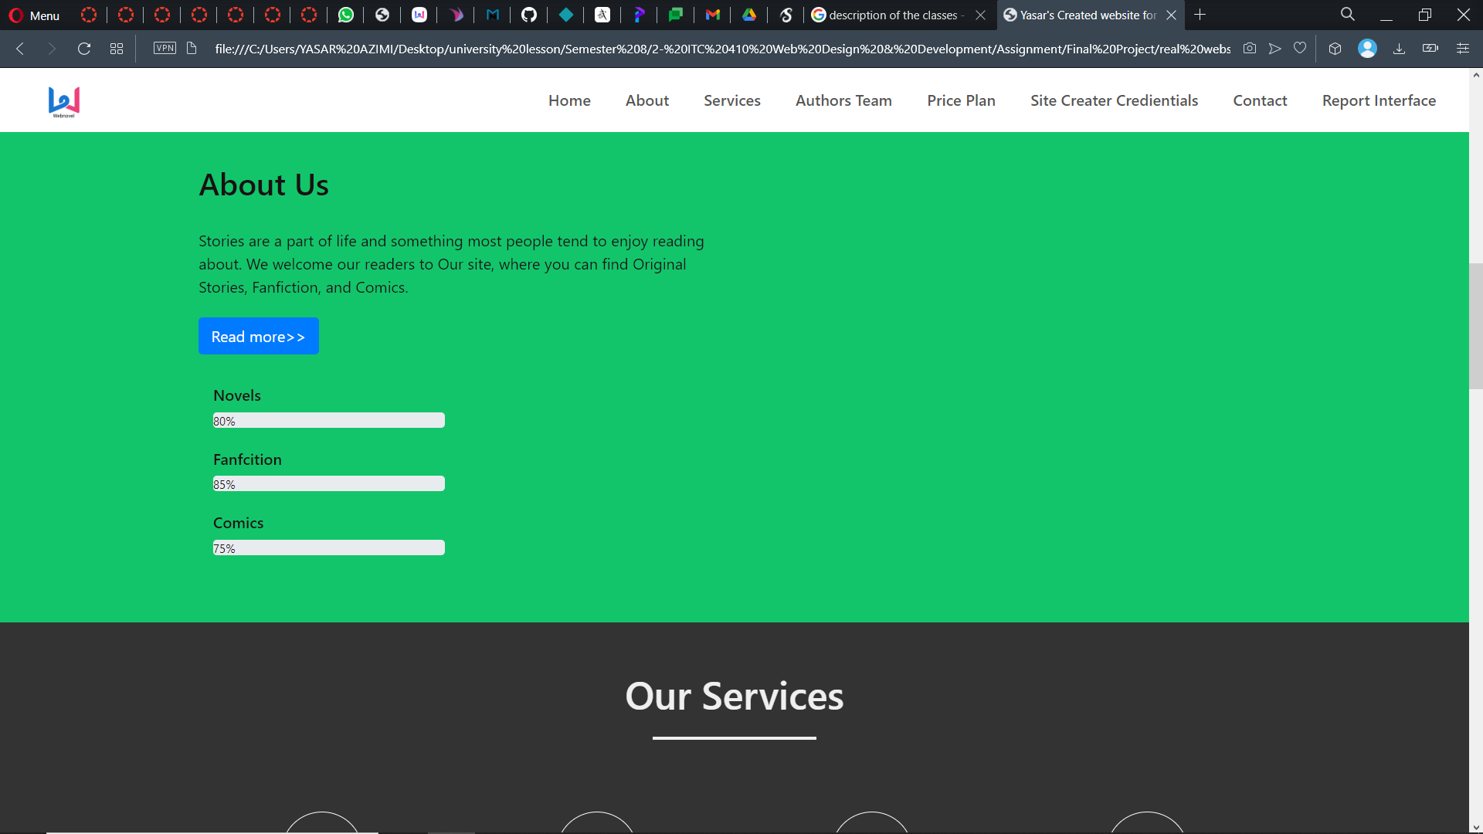

Then checking our service you will get a detailed explanation on our sites workings. These includes what we have in our site for example The novels, The fanfics, The Comics, and the contests are all included in this.

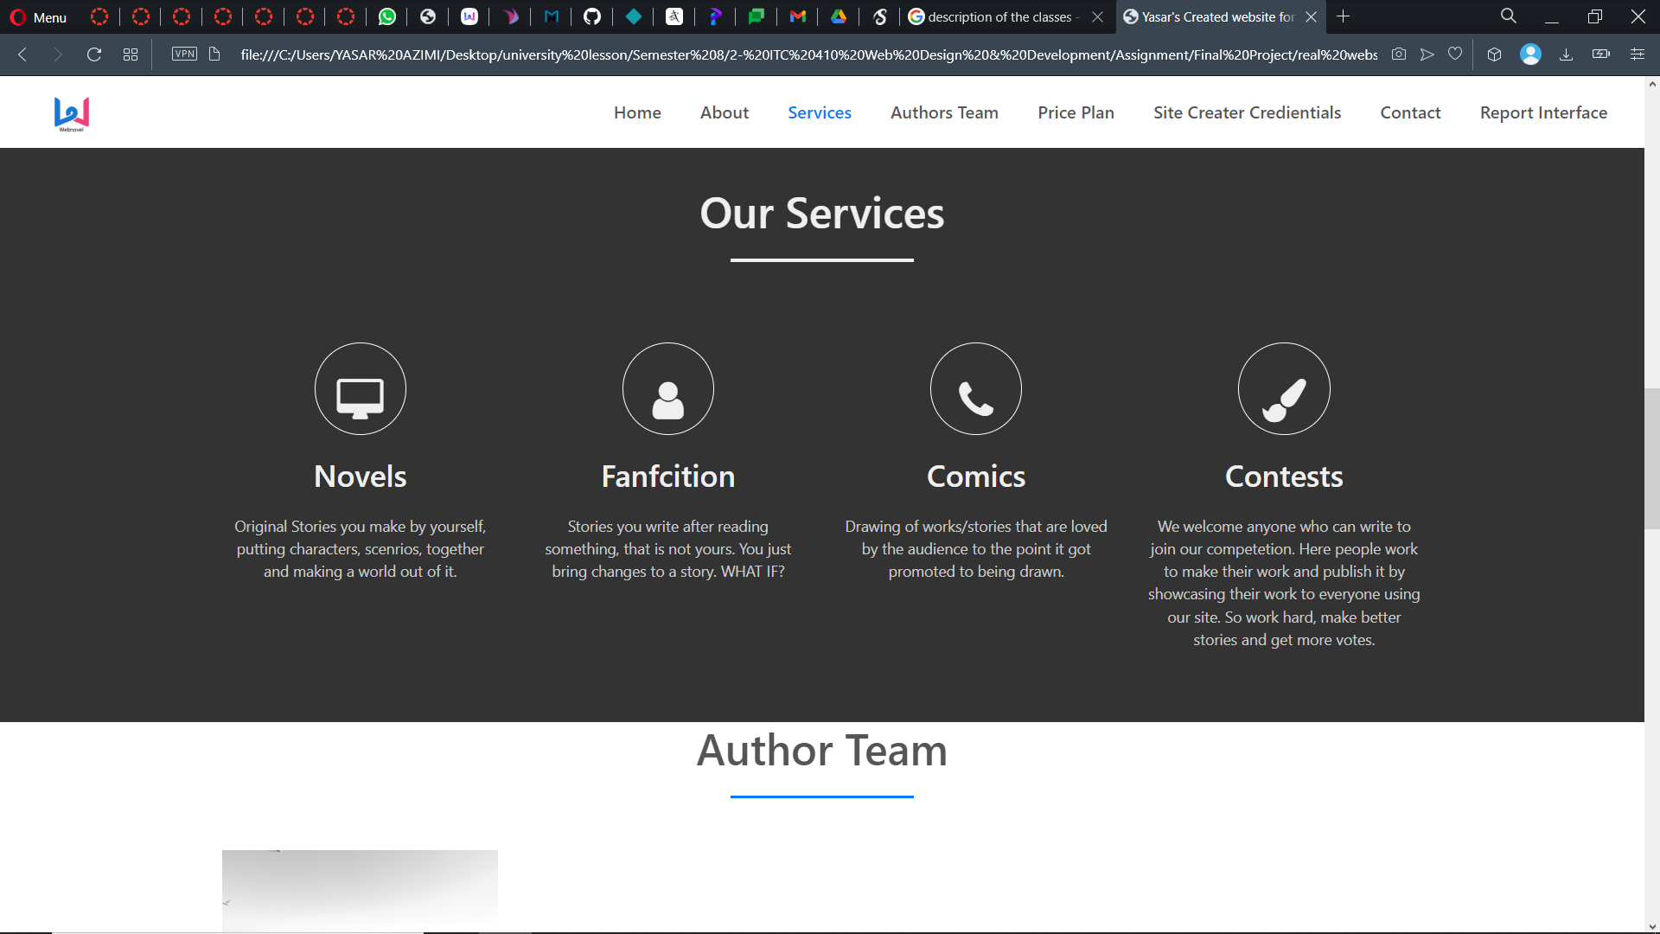

The next part is the Authors team of this site, those who are working and posting their stories at the site. But since its going to be launched soon it only has 1 person. It will have a basic information about the authors and the link to their social media accounts, including Facebook, twitter and LinkedIn.

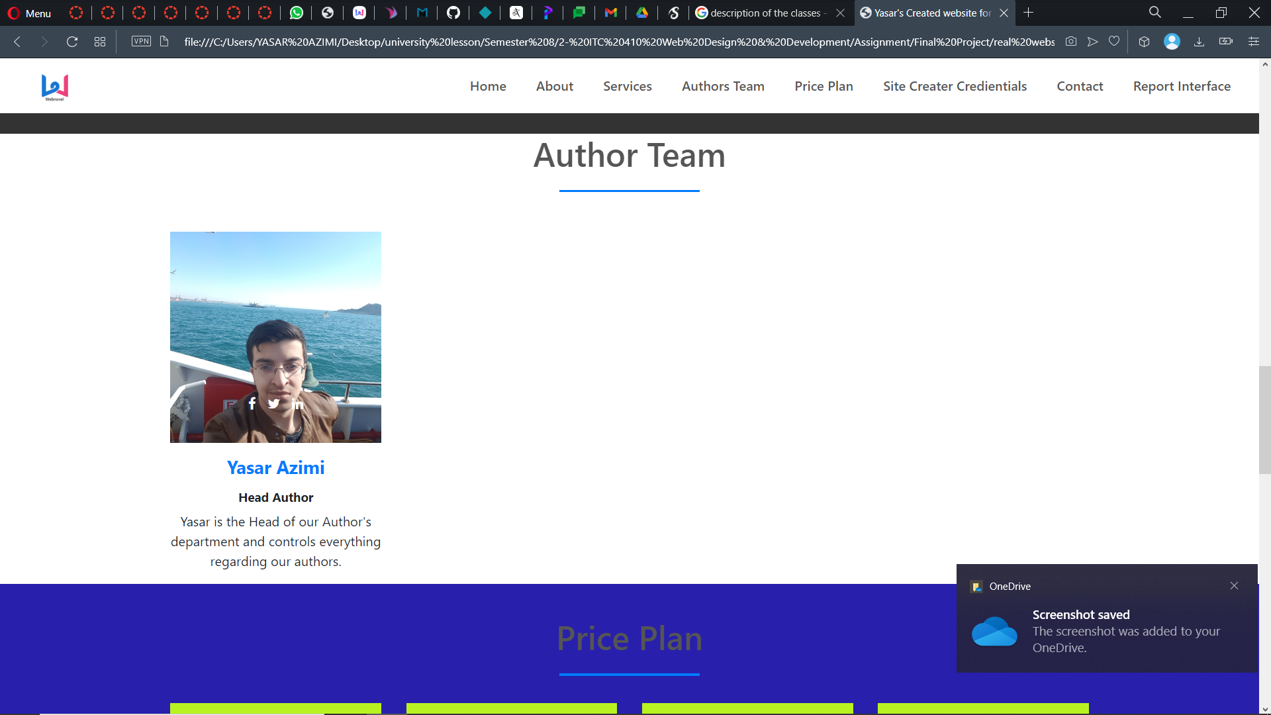

The next part is the price plan, this part includes what you will see in our site the and the price of it. If you want to download something, and the amount you can read at a time. We have plans from free upto advanced.

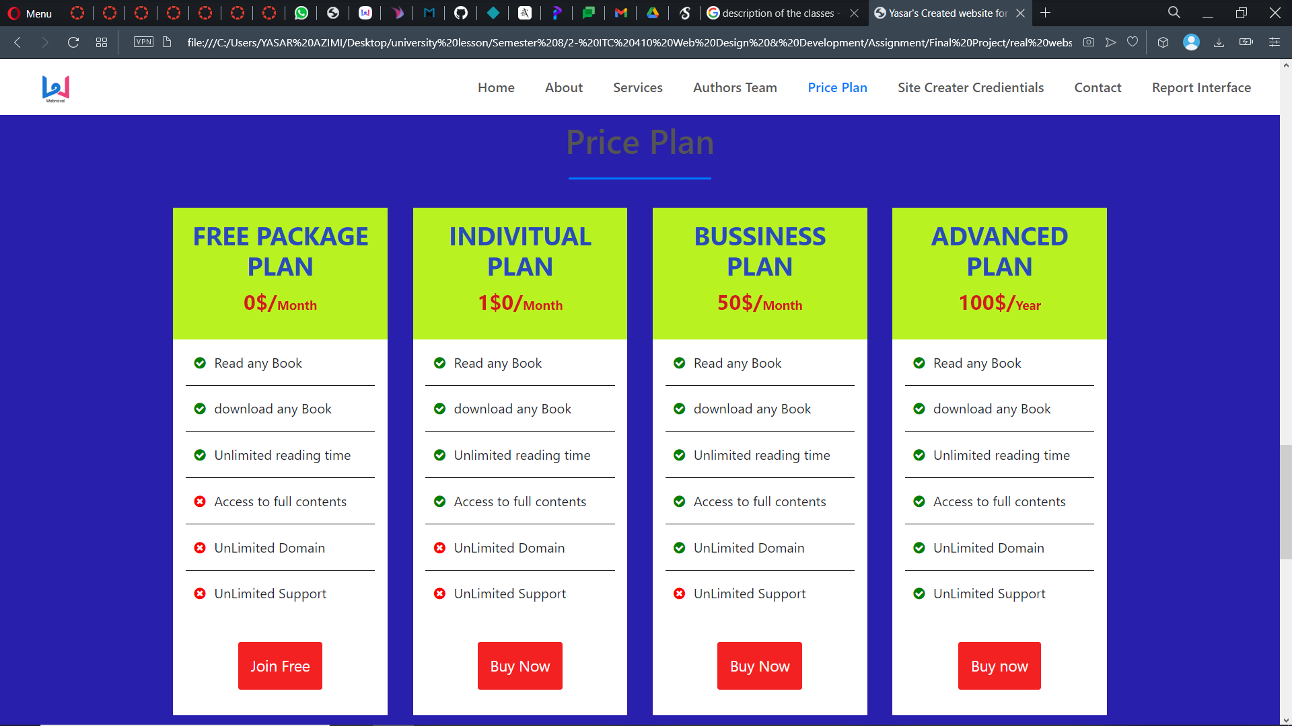

Then we have credentials that contains the info about the creator of this site.

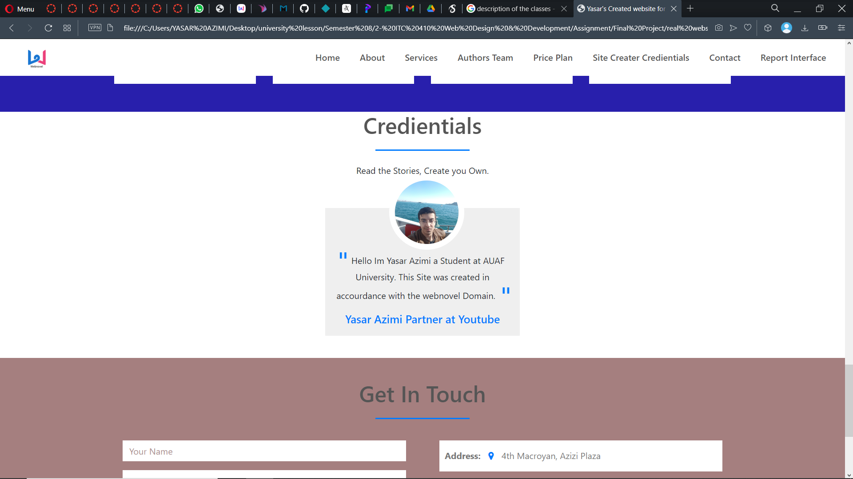

And after that we have contact which gives you the information needed to contact us personally if you want.

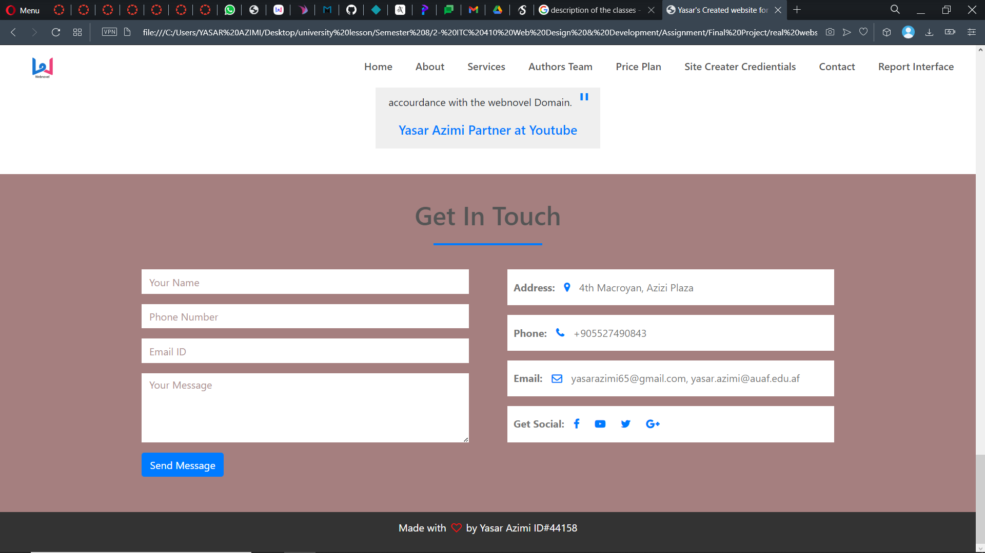

After this we have report interface that shows us info on who has read our books, and for how long. The amount of time that our site has been used.

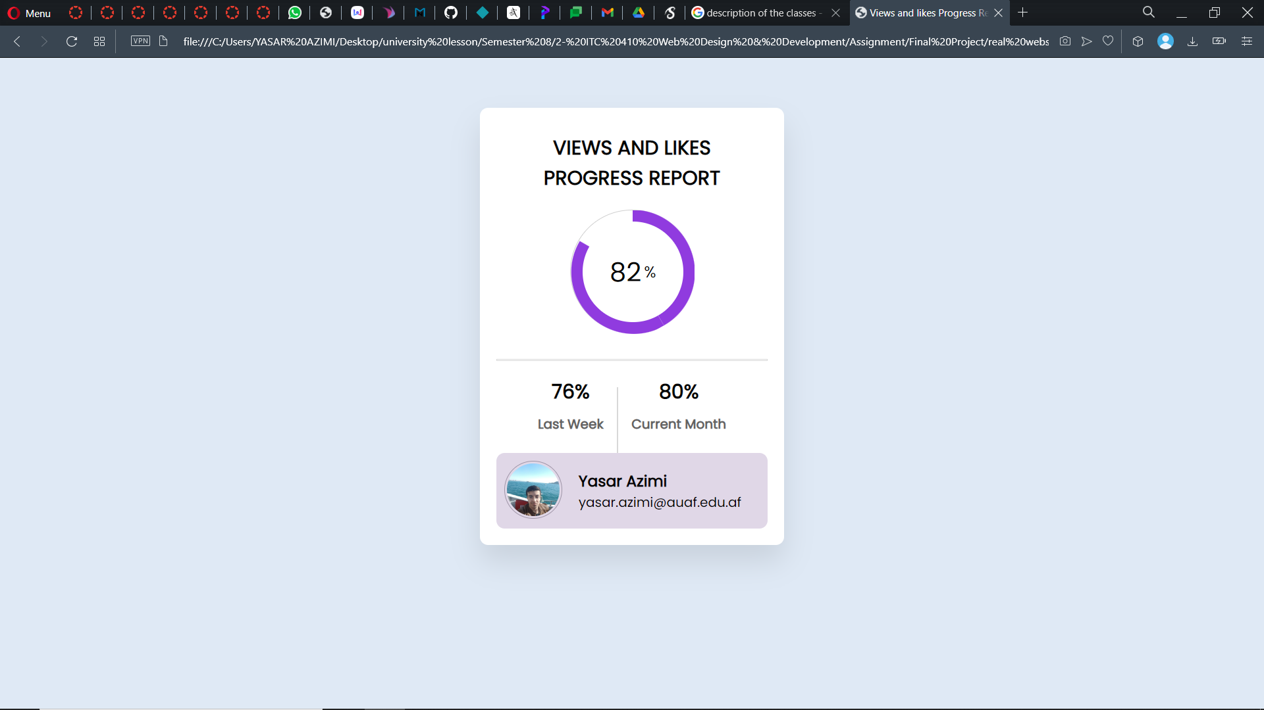

Then we have the final where you can get access to the website of NOVEl’S and start to read. This part is called “Start Reading”. And you just have to click on it.

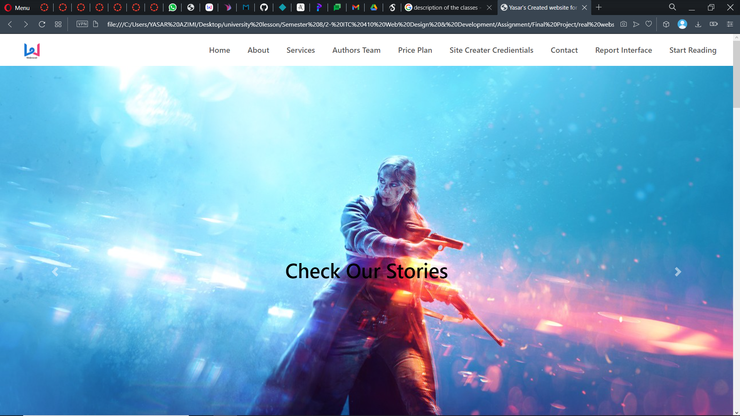

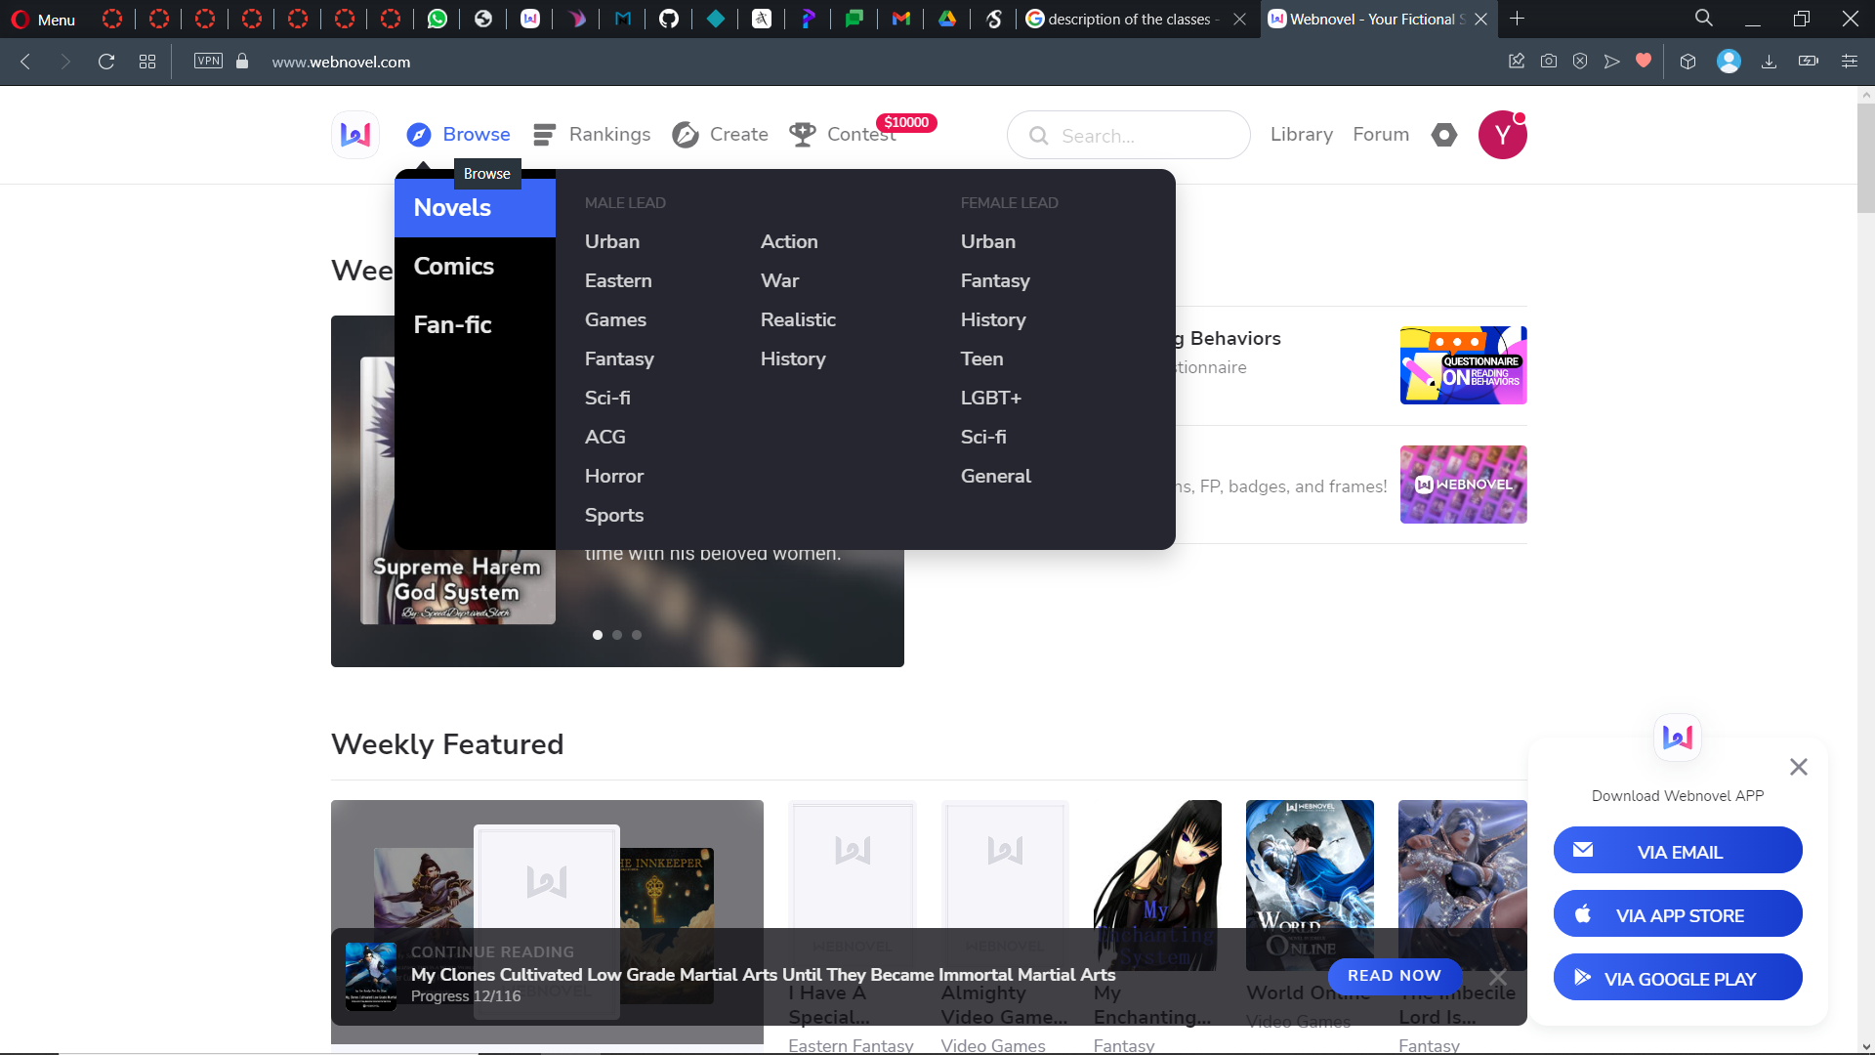

Link to the video in Google drive for the full video:

<https://drive.google.com/file/d/1yp9q8BqwOxv7oOLZQrKMvqSMs4OJS715/view?usp=sharing>